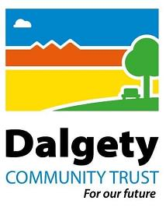

DALGETY COMMUNITY TRUST
ANNUAL GENERAL MEETING
22nd March 2025 commencing at 12.00
Meeting to be held at The Kabin, Dalgety Bay
AGENDA
- Introduction from the Chair
  - Purpose of the meeting
  - Order of business
- Agree minutes from Annual General Meeting held on 25th October 2023
- Chairs report of the activities of the company since the previous Annual General Meeting
- Treasurer’s report
- Election of directors
- Questions from members
- Any other business
- Closing remarks

